Java Source Code Example for the Decorator Design Pattern - GUI Application
Decorator Design Pattern is applied in Graphical User Interface toolkits to add dynamically windows behaviors.
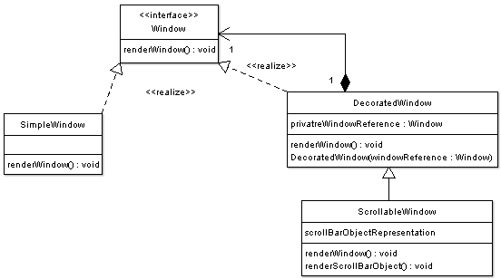

The code below illustrates the Window interface representing the component interface.
package decorator;

/**
* Window Interface
*
* Component window
*/
public interface Window {

public void renderWindow();

}
The code below illustrates concrete window implementation:
package decorator;

/**
* Window implementation
*
* Concrete implementation
*/
public class SimpleWindow implements Window {

@Override
public void renderWindow() {
// implementation of rendering details

}
}
The code below illustrates the basic decorated window implementation. Note that the decorator maintains a reference to a window object that is being decorated.
package decorator;

/**
*
*/
public class DecoratedWindow implements Window{

/**
* private reference to the window being decorated
*/
private Window privateWindowRefernce = null;

public DecoratedWindow( Window windowRefernce) {

this.privateWindowRefernce = windowRefernce;
}

@Override
public void renderWindow() {

privateWindowRefernce.renderWindow();

}
}
The code below illustrates a scrollable window which is a decorated window
package decorator;

/**
* Concrete Decorator with extended state
*
* Scrollable window creates a window that is scrollable
*
*
*/
public class ScrollableWindow extends DecoratedWindow{

/**
* Additional State
*/
private Object scrollBarObjectRepresentation = null;

public ScrollableWindow(Window windowRefernce) {

super(windowRefernce);
}

@Override
public void renderWindow() {

// render scroll bar
renderScrollBarObject();

// render decorated window
super.renderWindow();
}

private void renderScrollBarObject() {

// prepare scroll bar
scrollBarObjectRepresentation = new Object();

// render scrollbar

}
}
The code below illustrates a driver program for the window component. Note how the scrolling functionality has been added dynamically at runtime.
package decorator;

public class GUIDriver {

public static void main(String[] args) {

// create a new window

Window window = new ConcreteWindow();

window.renderWindow();

// at some point later
// maybe text size becomes larger than the window
// thus the scrolling behavior must be added

// decorate old window
window = new ScrollableWindow(window);

// now window object
// has additional behavior / state

window.renderWindow();

}
}

